Template I designed:
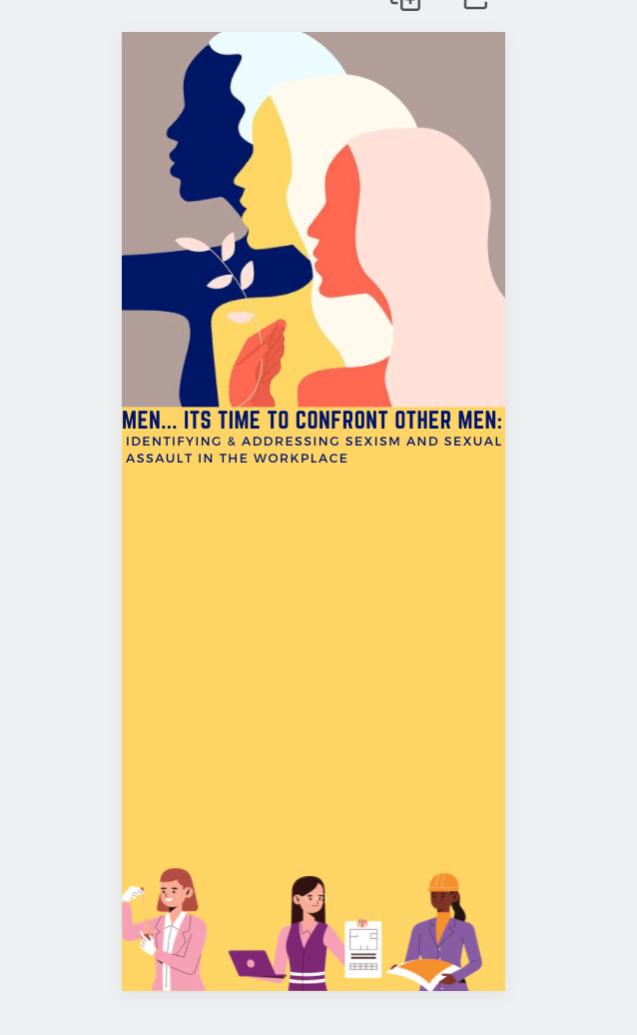
https://www.canva.com/design/DAEnm2cG8-4/F3hPAFfEyzcO4Ck7LgKhCA/edit

The goal is to educate future male employees on how to proactively identify and address issues of sexism and sexual assault in the work setting. (how to be an ally to women, use privilege, etc.)

- define key words/concepts
- explain the problem
- provide examples
- identify strategies
- include additional resources

infographic could be printed or distributed online

Content..need to cite, ID what I want to use
Sources:
https://hbr.org/2020/10/how-men-can-confront-other-men-about-sexist-behavior

Confronting other men for sexism, bias, harassment, and all manner of inappropriate behavior may be the toughest part of male allyship.

https://promundoglobal.org/resources/male-allyship/

inequalities between men and women: hiring, salary, benefits, mentoring, promotion
Twenty-two percent of women report being sexually harassed at work compared to 7
percent of men (2017

Out of 12 actions shared in the focus groups on how men can help advance gender equality at
work, those with the most agreement among women and men included:
• Let other men know when what they are saying is inappropriate for a work setting
• Point out when credit for an idea or project is due to your female coworker
• Openly defend women who are targets of sexual harassment by male associates
• Advocate for equal pay

Despite this list of steps to take, many men acknowledged that it can be difficult to take action (however it is essential)

Pg16 starts with allyship of men steps

https://www.theguardian.com/sustainable-business/2016/jun/08/workplace-gender-equality-invisible-privilege
advancing women in the workplace—lack of interest from men, underestimating the problem

“Privilege is invisible to those who have it.”

https://www.rainn.org/articles/sexual-assault

Attempted rape
Fondling or unwanted sexual touching
Forcing a victim to perform sexual acts, such as oral sex or penetrating the perpetrator’s body
Penetration of the victim’s body, also known as rape

https://www.nolo.com/legal-encyclopedia/what-kinds-of-behaviors-are-considered-sexual-harassment.html#:~:text=Some%20workplace%20conduct%20is%20clearly,catcalls%2C%20ogling%2C%20or%20cornering%20someone

“Some workplace conduct is clearly sexual harassment—for example, unwanted kissing, touching of breasts or genitals, butt slapping, rape, other forms of sexual assault, requests for sexual favors, making sexually explicit comments, uninvited massages, sexually suggestive gestures, catcalls, ogling, or cornering someone in a tight space.”

Examples:

repeated compliments of an employee's appearance
commenting on the attractiveness of others in front of an employee
discussing one's sex life in front of an employee
asking an employee about his or her sex life
circulating nude photos or photos of women in bikinis or shirtless men in the workplace
making sexual jokes
sending sexually suggestive text messages or emails
leaving unwanted gifts of a sexual or romantic nature
spreading sexual rumors about an employee, or
repeated hugs or other unwanted touching (such as a hand on an employee's back).

vPhoto by Nataly Menjivar on
behance
· · · International Women's Day 2018
https://www.behance.net/gallery/62982649/International-Womens-Day-2018

