Joanna Vines
WRT 205
Professor Oakes
August 8, 2021
Annotation
In “Views of racial inequality”, by Julianna M. Horowitz, Anna Brown, and Kiana Cox, a wide range of racial disparities are touched upon. Because this source come from Pew Research Center, there are many graphs and charts which are the results of multiple surveys. In other words, this piece provides an abundance of quantitative data that looks at racial disparities through different lenses. Graphs focus on political parties’ views on racial advantages to showing how race limits an individual’s ability to get ahead.
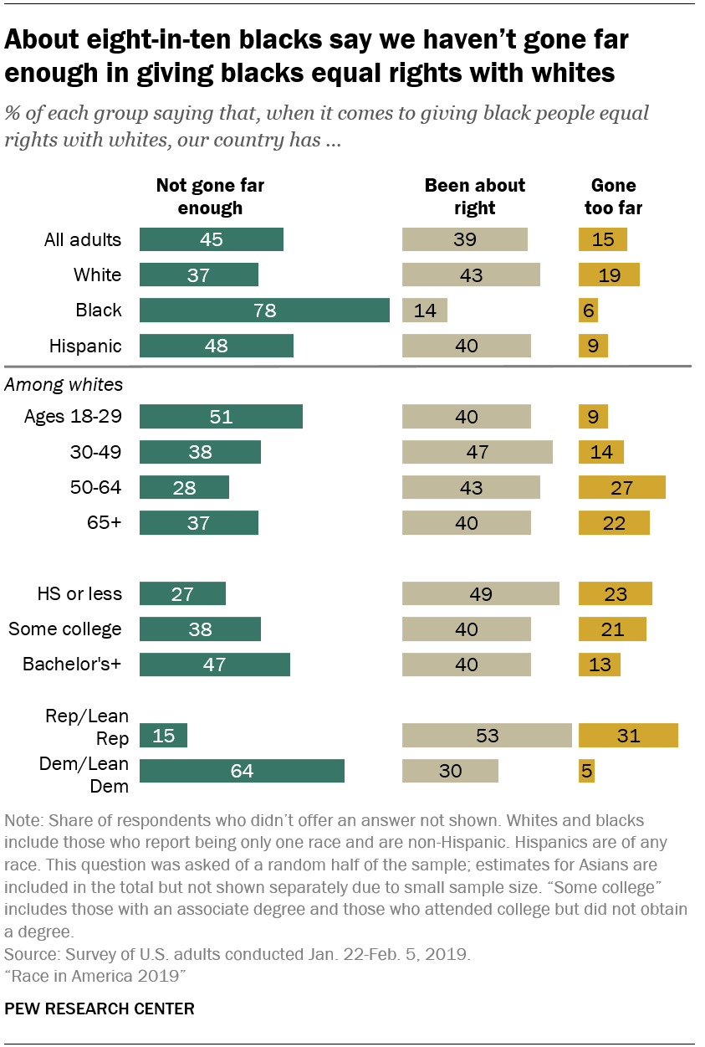
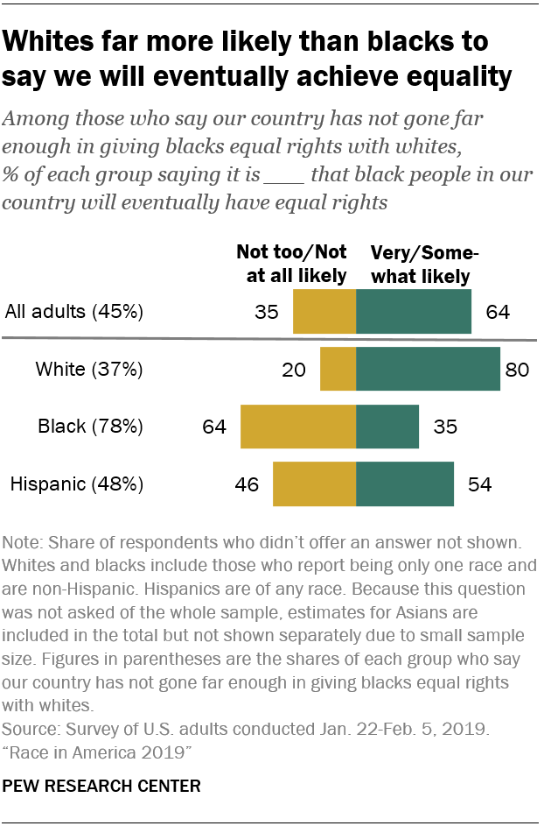
Unlike other pieces I have analyzed, this one discusses an array of racial injustices rather than just health and income. This article is unique because it is multiple paragraphs consisting of findings from multiple studies regarding racial differences. I found this piece useful because it expanded my understanding on other angles to the issue of racial injustices.

References

Horowitz, J. M., Brown, A., & Cox, K. (2020, April 9). Views of racial inequality. Retrieved August 5, 2021, from https://www.pewresearch.org/social-trends/2019/04/09/views-of-racial-inequality/

