Joanna Vines
WRT 205
Professor Oakes
August 8, 2021
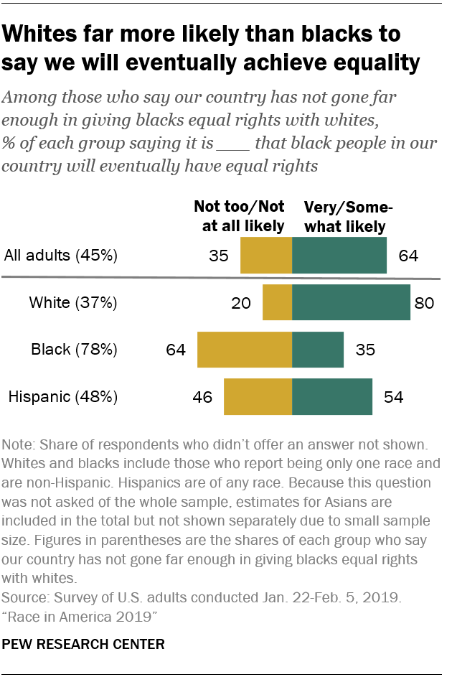Annotation
In the U.S. Department of Health and Human Services webpage “Social Determinants of Health” from Healthy People 2030, the five conditional domains of life that influence health status as well how the mission of Health People 2030 address them are discussed. Social Determinants of Health is defined as “the conditions in the environments where people are born, live, learn, work, play, worship, and age that affect a wide range of health, functioning, and quality-of-life outcomes and risks” (para. 1).The broad categories under the Social Determinants of Health are economic stability, education access & quality, health care & access, neighborhood & built environment, and social & community context. The website provides examples of these broader categories on a smaller scale. For example, access to safe housing, clean water, nutritious food all plays a role in an individual health and well-being. Additionally, exposure to racism, discrimination, and violence also influence health outcomes and the status of other health determinants.
This source was important to include in my portfolio because it provides the framework to understanding bigger issues that are discussed in other articles. It paints a clear picture of a very relevant concept that is tied into the economic and racial side of my topic. Additionally, the webpage provides links to other readings that can answer follow up questions or expand research.
References
U.S. Department of Health and Human Services. (2021, August 7). Social Determinants of Health - Healthy People 2030 | health.gov. Retrieved August 4, 2021, from https://health.gov/healthypeople/objectives-and-data/social-determinants-health

