Joanna Vines
WRT 205
Professor Oakes
August 8, 2021
Annotation
In “Discrimination and Health Inequities”, author and professor of epidemiology at Harvard, Nancy Krieger prefaces her article by establishing a general understanding of the relationship between level of income and mortality rates. This article expands on this idea by considering how race influences these other variables. Krieger believes this is an important area to explore given that socioeconomic position (SEP) is the strongest predictor of individual/population health and that economic factors vary among racial and ethnic groups. Within this article, there is a study that uses three measures of income inequality (Gini coefficient, 80/20 income share ratio, and proportion of income held by the least well-off 60 percent of the population) to understand a potential association between income inequality and age adjusted all-cause mortality among black and white people. The research found that these differences do not occur within racial groups but between them. The results also suggest that the health consequences of income inequality differ between racial group. One of Krieger’s proposed explanations is capitalism since it is a white benefiting system that control the United States economy. Furthermore, her findings posed the question of how gender identity may play a role in creating more disparities.
Even though, this scholarly journal was complicated and lengthy, it included clear data driven findings that are relevant to the topic of my portfolio. This source is full of information that was difficult to break down into a critical summary because it delves into many topics regarding race, economics, and health indicators. However, reading this source has given me a greater understanding of these issues and has provoked/answered questions that has pushed me to further my research on this topic.
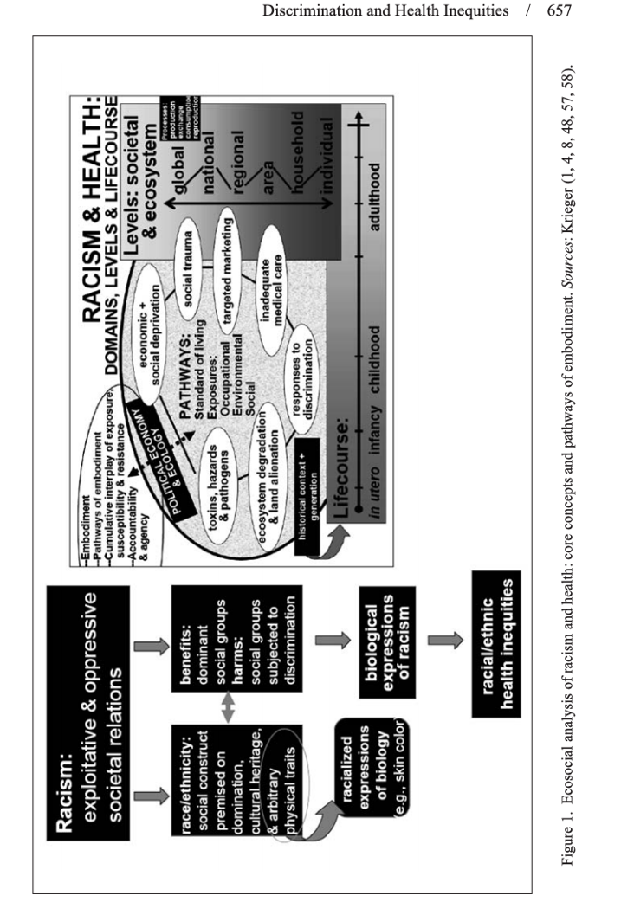
References
Krieger, N. (2014, October 1). Discrimination and Health Inequities. Retrieved August 4, 2021, from https://journals.sagepub.com/doi/10.2190/HS.44.4.b

